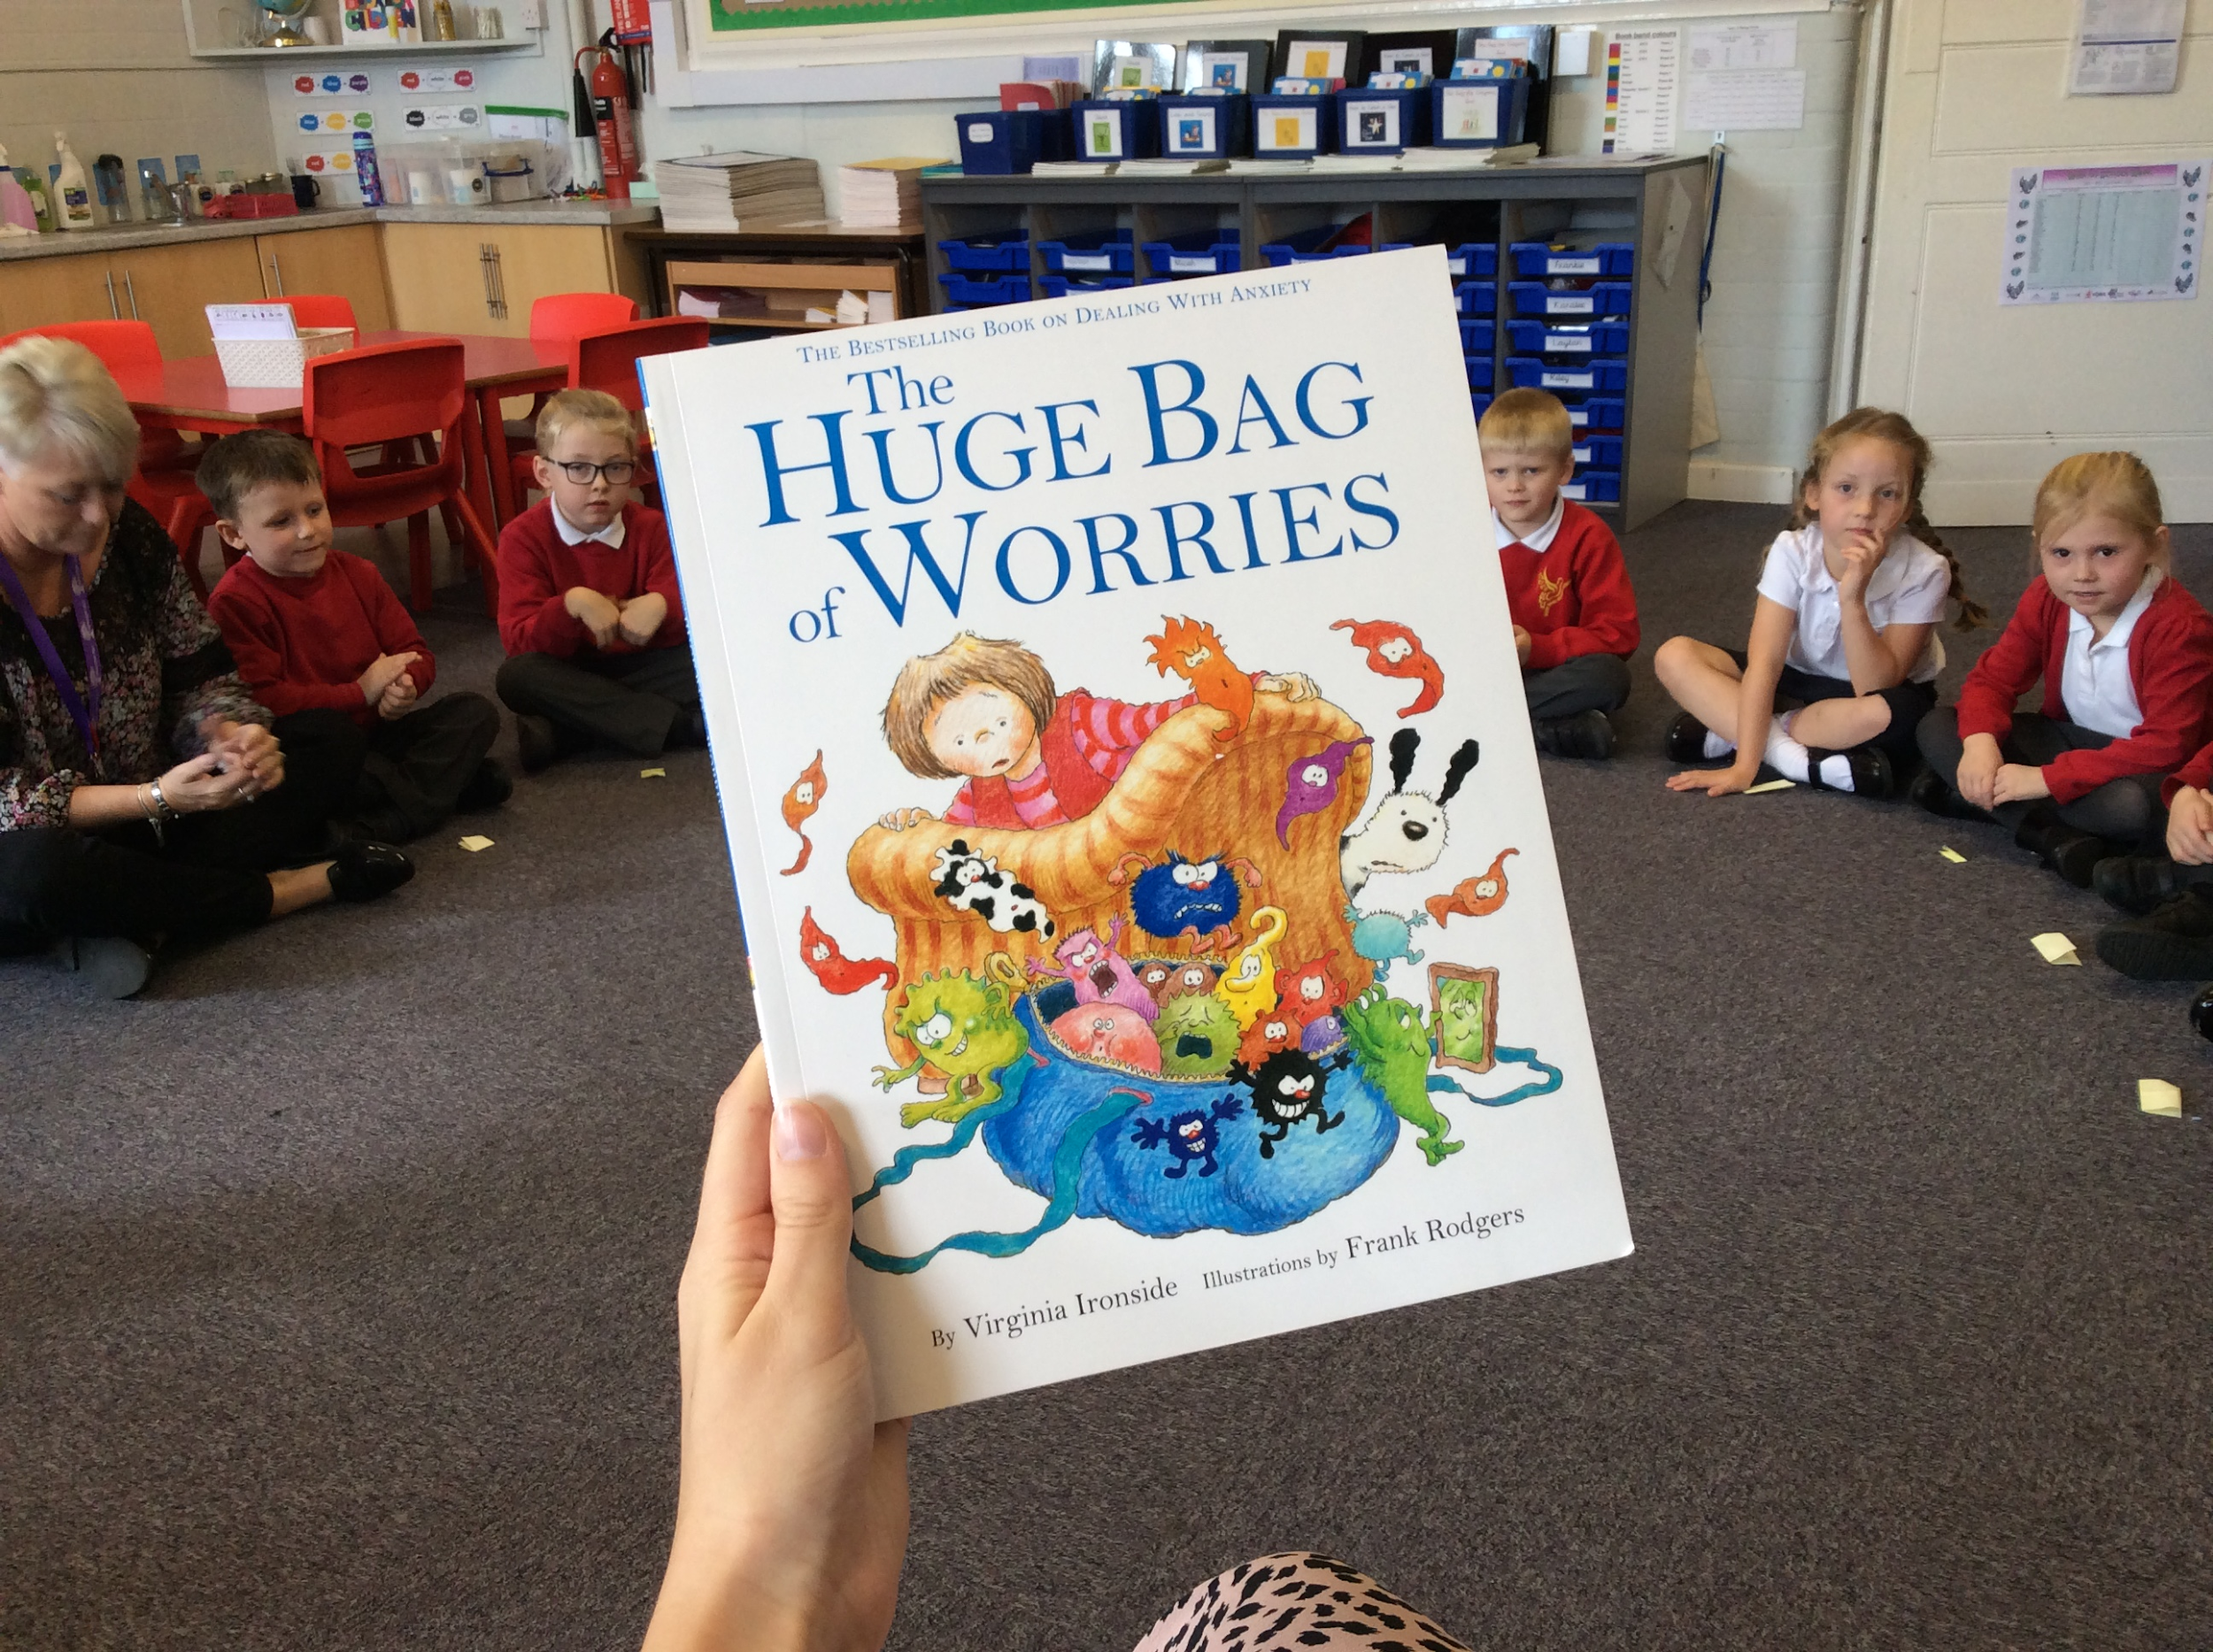
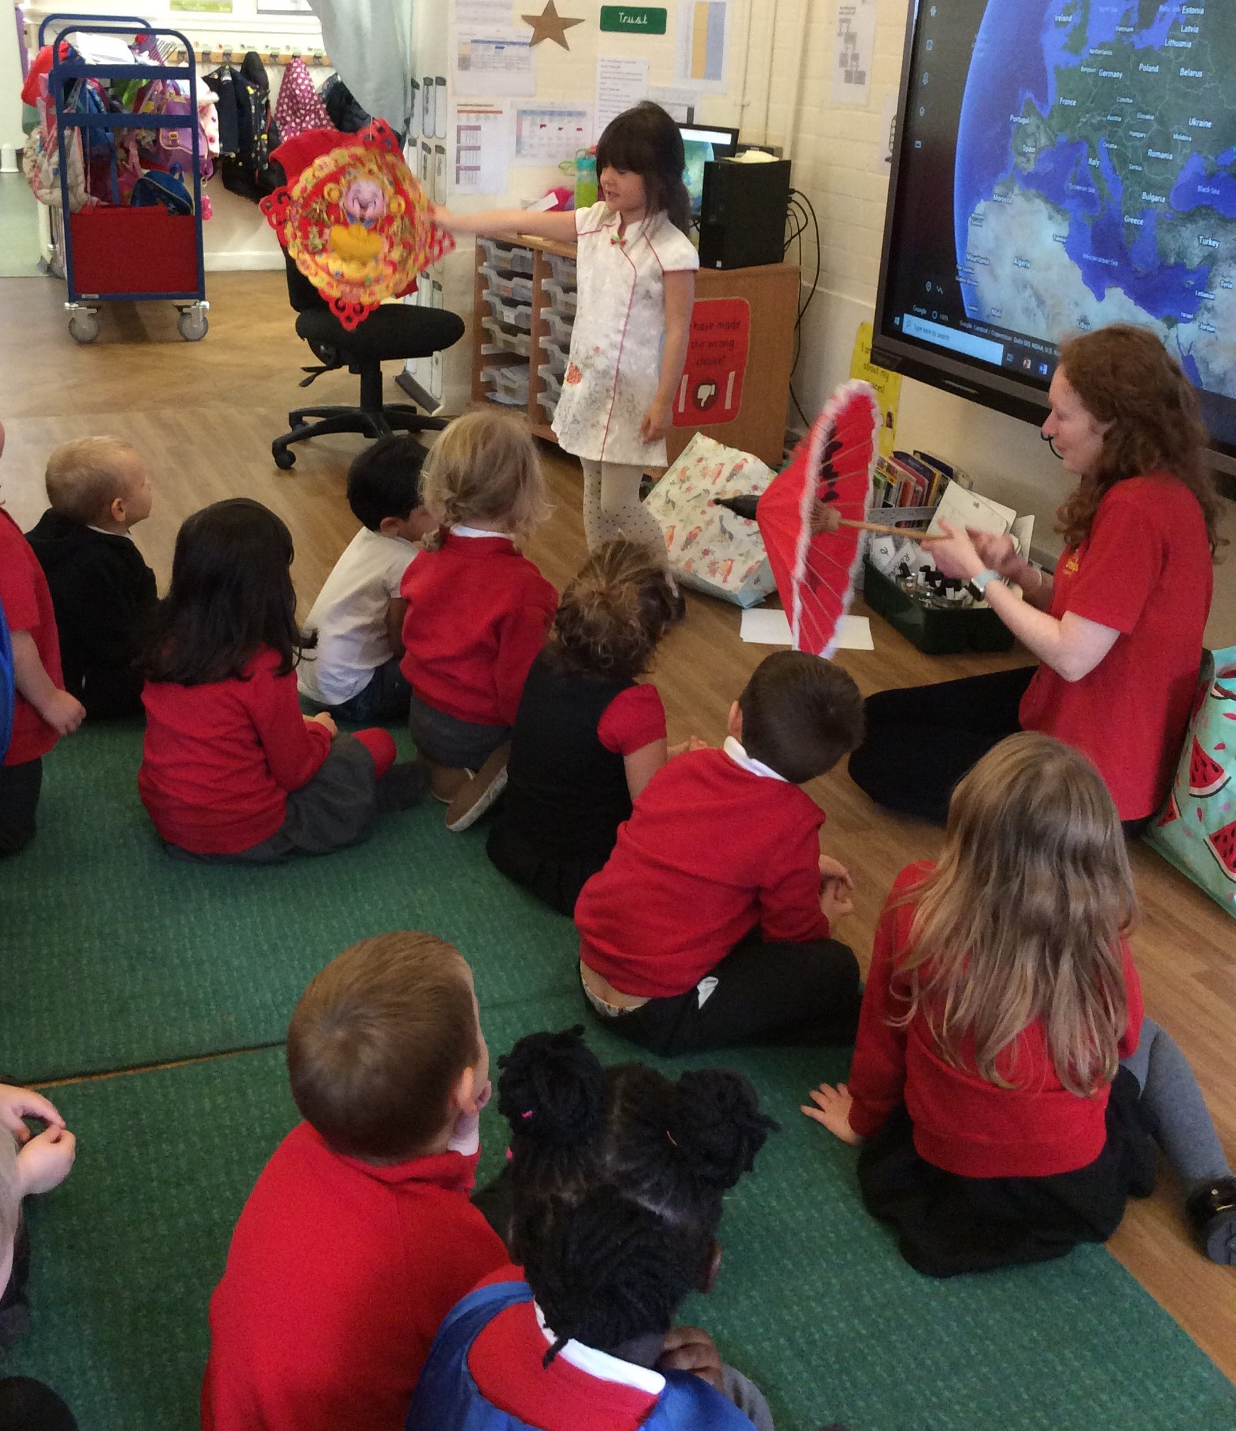
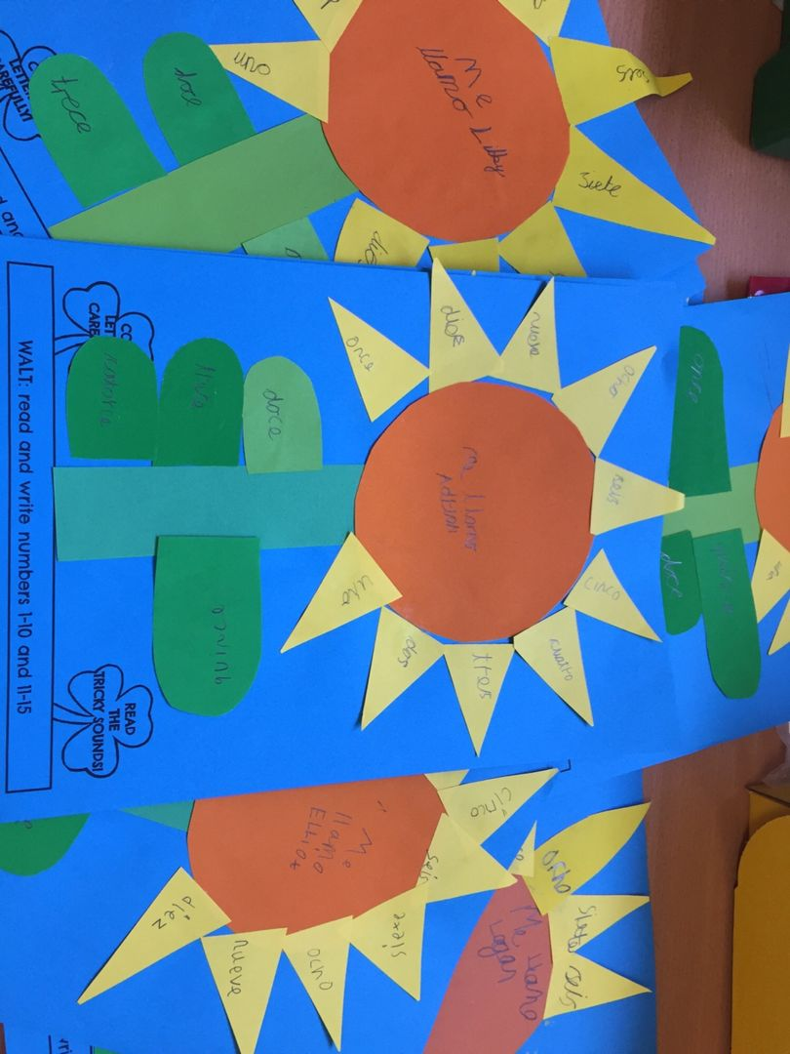
Tiny Steps

This week in Tiny Steps the children have been enjoyed exploring different types of pumpkins and their textures, looking inside them and toasting the pumpkin seeds, they were delicious!!!
They have also been role playing ice cream shops, which they then got to taste their favourite flavours.
Nessgate:
This week Year 2 have explored their new class book ‘The Day The Crayons Quit’, researched John Sentamu as part of Black History Month, wrote some lovely letters to Minster Grange Care Home and created a class Worry Jar whilst discussing our well-being!

Music: A week of wonderful behaviour in music this week with 100% effort from everyone. We are learning music in very different ways now & everyone is being challenged with exciting no-singing and no-instrument activities. We are studying iconic musicians for Black History Month & learned about Bob Marley this week, listening to ‘Jammin’ by Bob Marley and the Wailers.
Haxby Road Primary Academy
Curriculum Newsletter 9.10.20
Reception:
This week we had a journey around the world thanks to one of our class members! She showed us outfits, photos and objects from the different countries she has lived in or visited.
We loved seeing the
Chinese New Year
items!

Nursery:

This week Nursery have spent time exploring different autumnal colours and textures. We have also roleplayed going on holiday, sharing our own experiences.
Spanish:
Y3 have been learning to write numbers in Spanish this week. Look at our lovely sunflowers inspired by the book
‘Diez Semillas’!
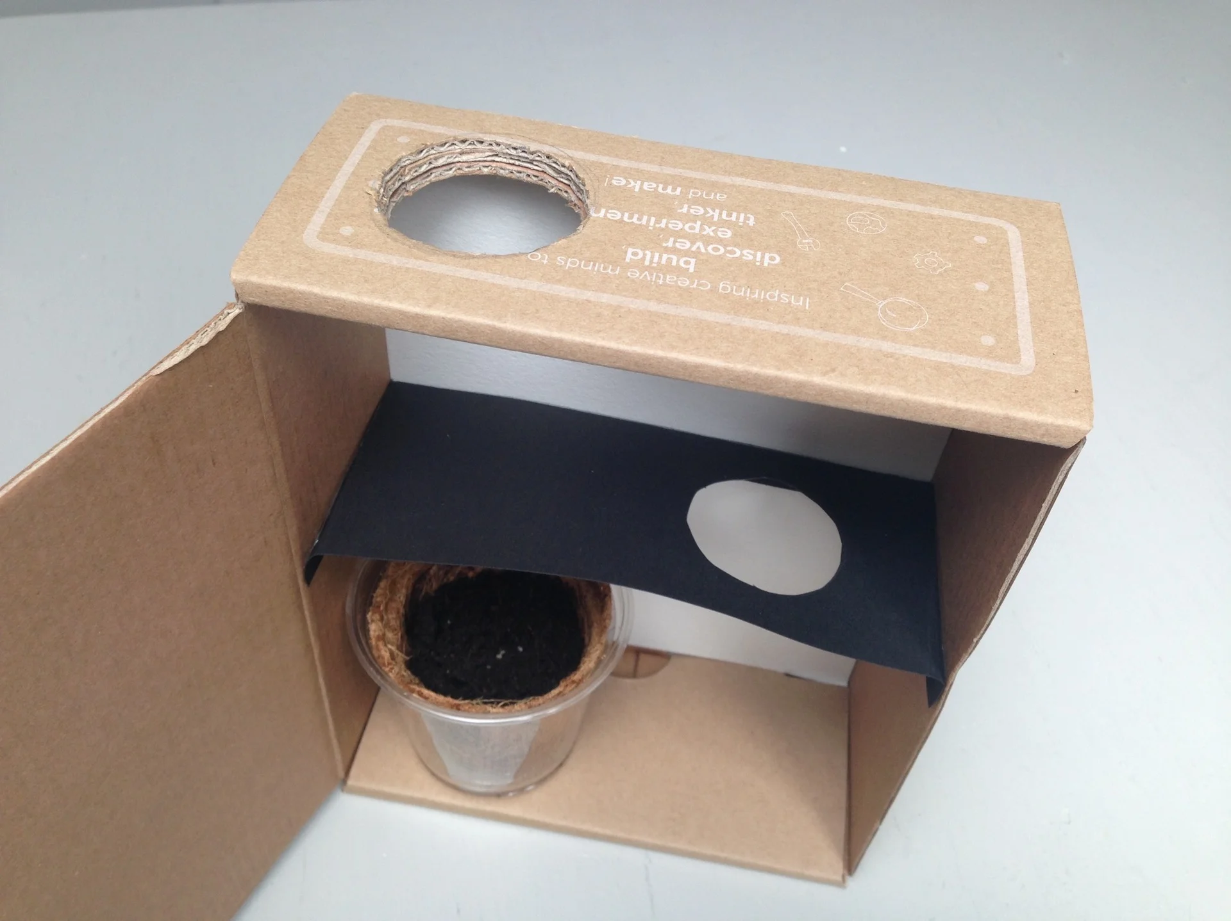
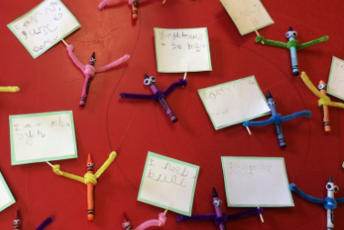
Fossgate:
This week we have been using our scientific knowledge about Phototropism.
The children have built a plant light maze, to hopefully watch the plants grow around the obstacles!

Whip-Ma-Whop-Ma-Gate:
This week we started our new class book, ‘The Day the Crayons Quit’. We made little characters, thinking really carefully about their feelings! We love them!

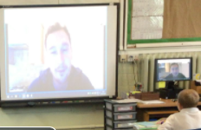
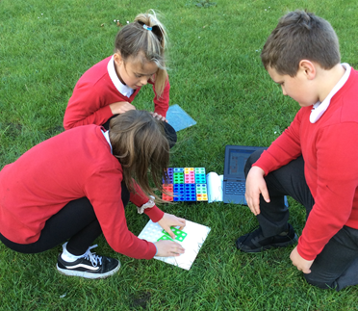
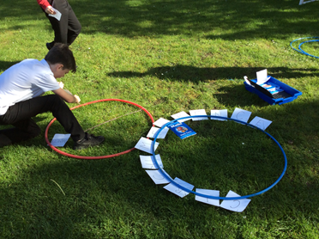
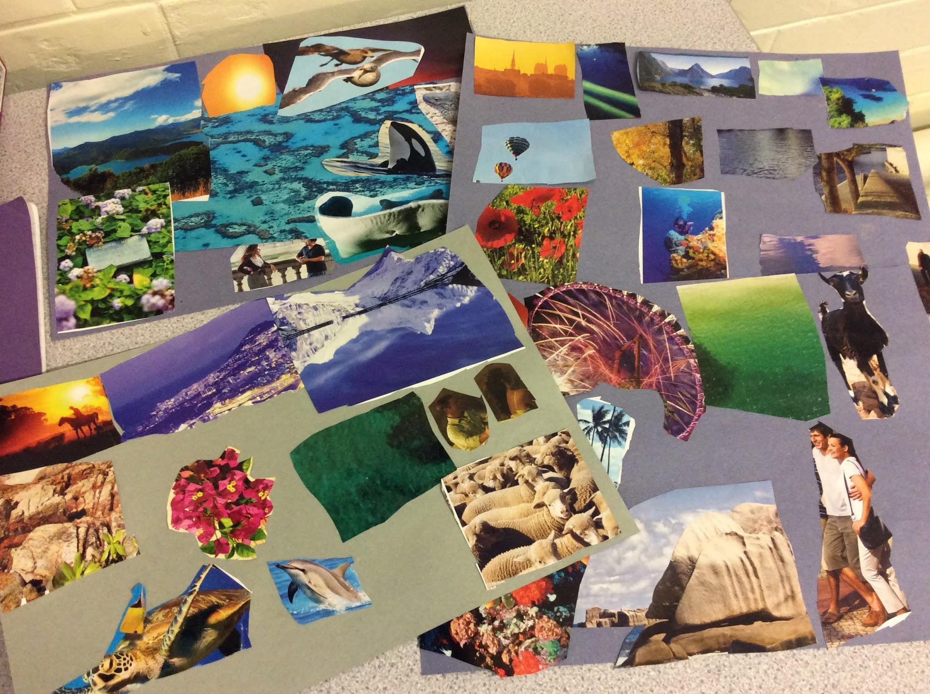
Micklegate
This week Micklegate have been creating newspaper reports after The House with Chicken Legs was spotted on Haxby Road! We interviewed an eyewitness to include speech in our work.
Stonegate
Year 6 had a fabulous time working on a circuit of maths activities outside. They had to use their problem solving skills to complete a range of challenging activities.
Gillygate
This week we have been learning about why the Bible is important to Christians. We listened to the Creation story and made our own Creation collages. In Maths we made counting in 50s paper chains.
ERP:
ERP1 had a crime scene to investigate! What had happened to The Gingerbread Man? They then designed and created their own Gingerbread Men. ERP2 & 3 researched Italy and cooked some delicious pizzas! Did you know they made a pizza 40m wide in Italy?

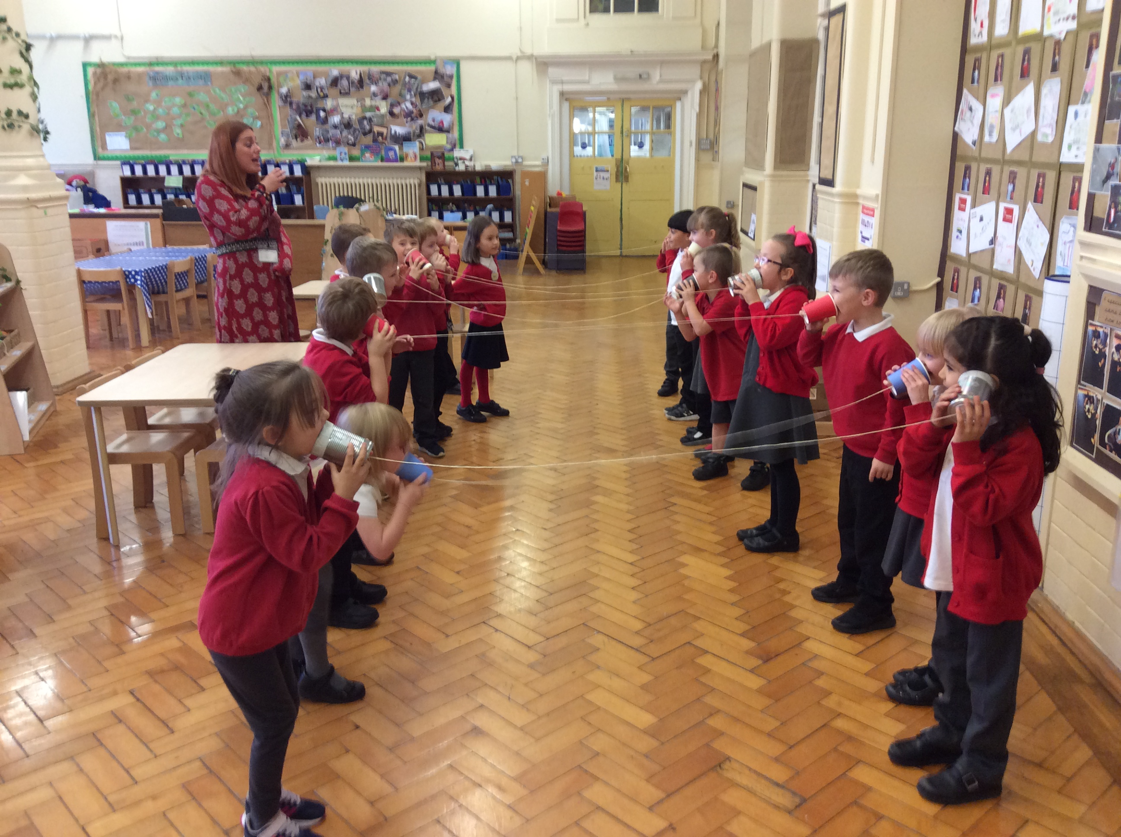
Fishergate:
This week we conducted a fair test to find out which material made the
best performing string telephone. The tin can phone ranked 1st place!

