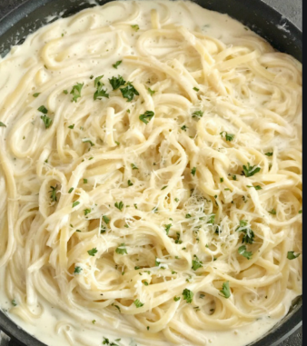
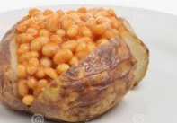
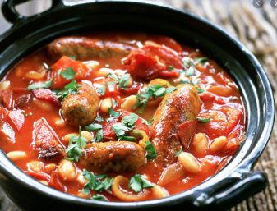
Tuesday 13th October

Tomato Pasta served with mixed veg
Or
Creamy cheese pasta served with mixed veg
Biscuit or Fresh Fruit

Monday 12th October

Jacket Potato served with beans
Or
Jacket Potato severed with cheese
Ice cream tub or Fresh Fruit
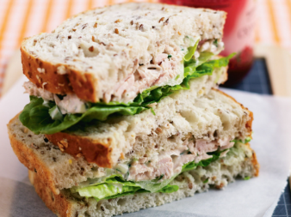
Wednesday 14th October

Sausage casserole and potatoes
Or
Quorn casserole and potatoes

Yoghurt or Fresh Fruit

Thursday 15th October

Ham sandwich with salad
Or
Tuna and mayo sandwich with salad

Biscuit or Fresh Fruit

Friday 16th October

Fish fingers served with chips & peas
Or
Quorn Dippers served with chips & peas

Ice cream tub or Fresh Fruit

