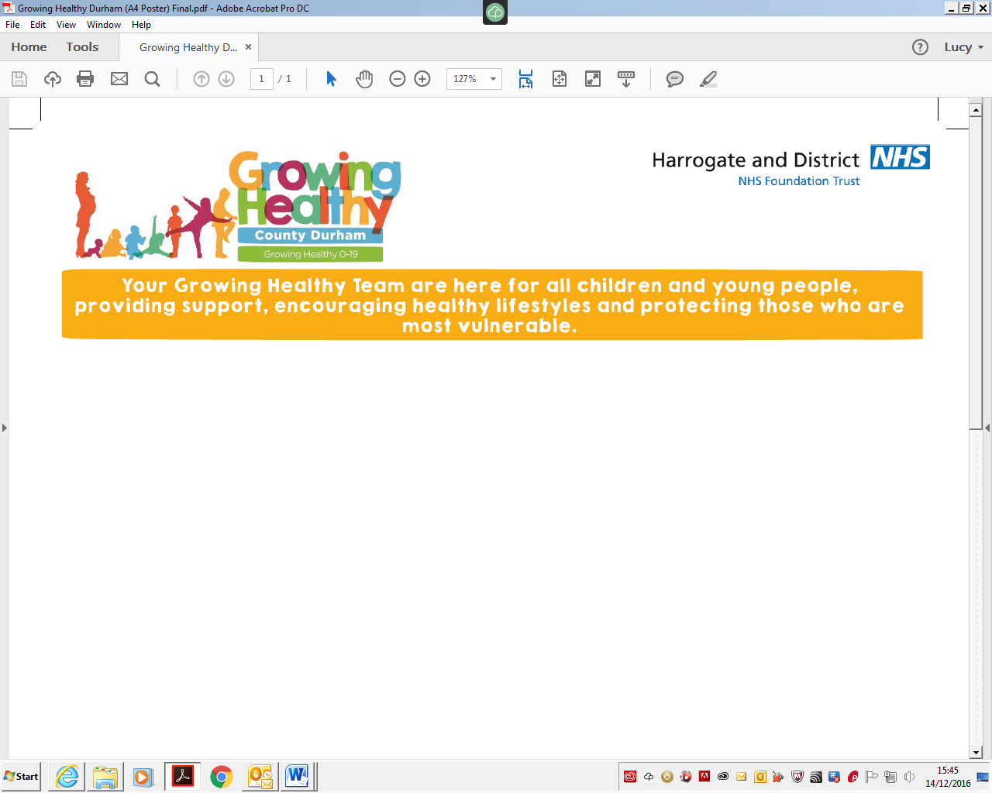



hdft.childhood.immunisations@nhs.net
01423 553115

November 2020
Dear Parent/Guardian,

CHANGE OF VENUE FOR YORK DROP-IN FLU CLINIC

Our scheduled drop-in flu immunisations clinic for children who missed out on receiving their flu vaccine in school this term now has a new venue. Though we had originally advertised this clinic as taking place at the York Sports Club on Shipton Road, due to the new lockdown restrictions the venue has taken the decision that they can no longer accommodate us.

We will instead be holding the York DROP-IN clinic at this address:

Rawcliffe Pavilion,
The Pavilion,
St Mark’s Grove,
York,
YO30 5TS

The date and time remains the same as originally advertised:

09:00-12:00pm, Saturday 14th November

This is a drop-in clinic. You do not need to contact us to make an appointment.

We apologise for any inconvenience caused.

Yours sincerely,

Childhood Immunisations Team

North Yorkshire and City of York
A NATIONAL HEALTH SERVICE FOUNDATION TRUST Chairman – Angela Schofield Chief Executive – Steve Russell

